Lab Report: Designing a VLSM Based Network with RIPv2

Course: CSE 4512 [Computer Networks Lab]
Name: Rafat Abdullah
ID: 220041102
Date: December 1, 2025
Section: 1B

Problem Statement:
We have to create a network for "Iutians Assemble" that allocates IP addresses efficiently based on a dynamic variable (Student ID) and ensures robust connectivity. The primary constraints are:
- Custom Addressing (VLSM): The network must use Variable Length Subnet Masking based on the formula derived from the last two digits of the Student ID ($i=02$).
- Reliability: The infrastructure must use a Ring Topology to ensure redundancy; if one link fails, traffic must reroute.
- Full Reachability: All 5 departments (Engineering, Marketing, Sales, Admin, Management) must communicate using dynamic routing.

Proposed Solution:
To address the requirements, we implemented a Ring Topology combined with RIPv2. The Ring topology was chosen because:
- It provides redundancy (two paths to every destination).
- It is cost-effective compared to a full mesh.
- RIPv2 allows for automatic route updates when the topology changes.

Screenshot of the final Network topology:
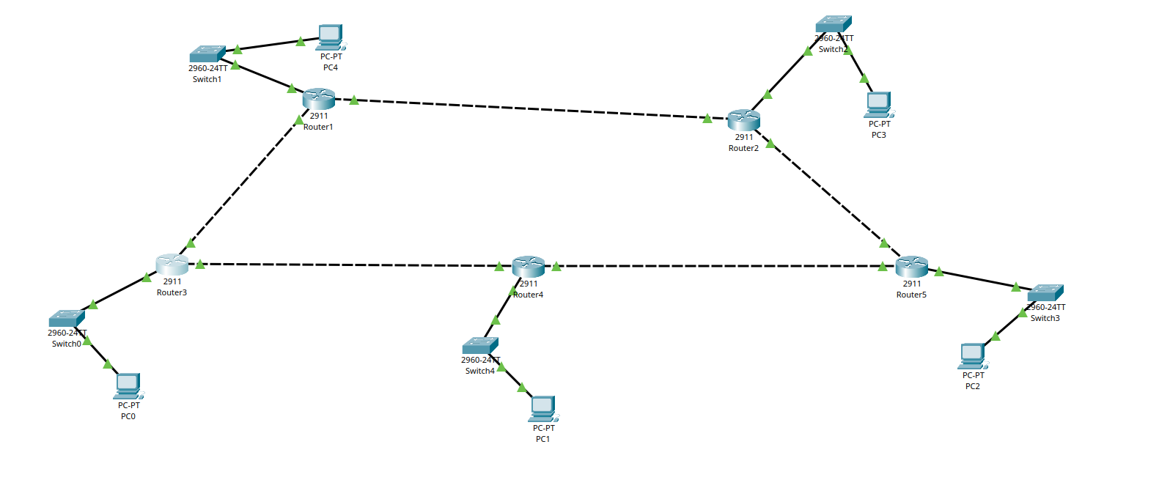

Short procedure:

Justification:
The VLSM approach was necessary because standard subnetting would waste too many addresses given the varying sizes of departments (from 34 hosts down to 2). The Ring topology ensures that if the link between Sales and Engineering breaks, traffic can still flow via Marketing $\to$ Admin $\to$ Management.

Logical design:
- Total Departments: 5 (Sales, Engineering, Marketing, Admin, Management)
- Total Routers: 5
- Routing Protocol: RIPv2 (Routing Information Protocol Version 2)

IP addressing scheme:
The base network 192.2.5.0/24 was used.

Device addressing table (LAN):
Department | Hosts Required | Subnet Mask | Gateway IP | Usable Host Range
Sales | 34 | 255.255.255.192 | 192.2.5.1 | 192.2.5.2 - 192.2.5.62
Engineering | 27 | 255.255.255.224 | 192.2.5.65 | 192.2.5.66 - 192.2.5.94
Marketing | 26 | 255.255.255.224 | 192.2.5.97 | 192.2.5.98 - 192.2.5.126
Administration | 8 | 255.255.255.240 | 192.2.5.129 | 192.2.5.130 - 192.2.5.142
Management | 2 | 255.255.255.252 | 192.2.5.145 | 192.2.5.146 - 192.2.5.146

WAN Links (Ring Connections):
- Sales - Eng: 192.2.5.148/30
- Eng - Mgmt: 192.2.5.152/30
- Mgmt - Admin: 192.2.5.156/30
- Admin - Mkt: 192.2.5.160/30
- Mkt - Sales: 192.2.5.164/30

Implementation Details:
Hardware Used:
- Routers: 5x Cisco 4321 (with NIM-2T Module)
- Switches: 5x Cisco 2960
- Cabling: Copper Straight-Through (LAN) and Serial DC (WAN)
Configuration Strategy:
The RIPv2 configuration used on every router to enable classless routing:
router rip
version 2
no auto-summary
network 192.2.5.0

Simulation Result and verification:
Connectivity verification:
The network was tested by sending Ping packets between the largest subnet (Sales) and the smallest subnet (Management).
- Result: 100% Successful.
- Observation: The first packet often failed due to ARP resolution, but subsequent packets succeeded.
Fault Tolerance Test:
To check redundancy, the serial link between Router 1 (Sales) and Router 2 (Engineering) was administratively shut down.
- Result: Ping from Sales to Engineering was still successful.
- Observation: The traffic successfully rerouted through the longer path (Sales $\to$ Mkt $\to$ Admin $\to$ Mgmt $\to$ Eng).

Challenges Faced During the Lab:
VLSM Calculation Complexity: Calculating the exact block sizes and ensuring no overlap between the subnets was challenging, especially fitting the /30 WAN links into the remaining space after the LANs.
Router Interface Mismatch: Initially, I connected the cables to the wrong serial ports (e.g., configuring S0/1/0 but plugging into S0/1/1). This caused the links to stay down. Using the "Show Port Labels" feature in Packet Tracer helped resolve this.
RIPv2 Configuration: I initially forgot the no auto-summary command. This caused the routers to treat the 192.2.5.0 network as a single class C network rather than distinct subnets, breaking connectivity. Adding the command fixed the routing table.

Conclusion:
The experiment successfully met the objectives of designing a scalable and reliable network. The VLSM implementation efficiently utilized the 192.2.5.0 address space, catering to the specific size requirements of each department. The implementation of RIPv2 on a Ring Topology ensured that the network remained fully operational even when a single link was severed, demonstrating effective fault tolerance.

